GPSHRM Hosts:
½ Day Workshop
Presented by:
Tony Moore, SHRM-SCP Chief Org Dev Officer w/Eckerd

Engaging In Difficult Dialogue

Wednesday, September 14th
8:30 am – 12:00 pm
Registration/Breakfast start
at 7:45 am
Pensacola Bay Center
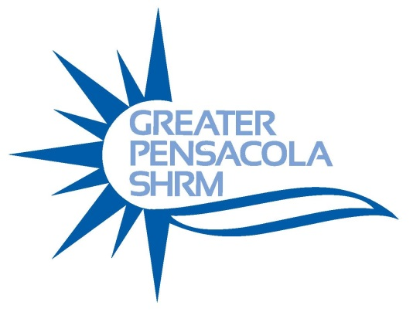
Approved for 3 credit hours
by HRCI and SHRM

Registration Only $60
Pre-Paid Lunch $40
Students Free
Engaging in Difficult Dialogue is designed to provide you the skills necessary to approach even the toughest conversations with confidence; allowing you to move from difficult to collaborative, from breakdown to breakthrough.

Learning Objectives
- Learn a four step strategic model for engaging in difficult dialogue
- Learn the critical factors that must be considered before engaging in difficult dialogue
- Learn how to choose opening lines that set the proper tone for engaging in difficult dialogue
- Learn the hidden meaning behind emotional outbursts, accusations, and defiance, as well the appropriate response for getting the conversation back on track

Tony Moore is an experienced Human Resource Executive, Speaker, Trainer, and self-proclaimed Leadership Fanatic. After spending several years working directly with children and youth, Tony came to recognize that although he had a heart for children, his greatest passion was the growth and development of his fellow employees. In his current role, Tony serves as Chief Organizational Development Officer. In this role Tony oversees Talent Management, Talent Development and serves as the organization’s point person in Eckerd’s merger, acquisition, and new business integration process.

